Level Shifting Experiment with LMC6484 and ESP32-DevKitC-V4

Objective
Configure and test a level-shifting circuit using the LMC6484 op-amp (Op-Amp D) to shift a triangle wave signal from −0.5V to +0.5V (generated by ESP32+AD5761) to an output range of 1.5V to 2.5V, using a bipolar ±5V power supply.

Circuit Configuration
- Op-Amp: LMC6484 (rail-to-rail CMOS), Op-Amp D.
  - Pin 8: Output (Vout), measured by oscilloscope.
  - Pin 9: Inverting input (−), connected to input signal via R1.
  - Pin 10: Non-inverting input (+), connected to Vref (1.0V).
  - Pin 4: V+ (+5V supply).
  - Pin 11: V− (−5V supply).
- Power Supply: Bipolar, +5V (Pin 4) and −5V (Pin 11).
- Input Signal: Triangle wave, −0.5V to +0.5V, generated by ESP32-DevKitC-V4 + AD5761 DAC.
  - Connected to Pin 9 through R1 = 10kΩ.
- Feedback Resistor: R2 = 10kΩ, connected between Pin 9 (inverting input) and Pin 8 (output).
- Reference Voltage: Vref = 1.0V, generated by a voltage divider circuit, applied to Pin 10.
- Output: Measured at Pin 8 using an oscilloscope.
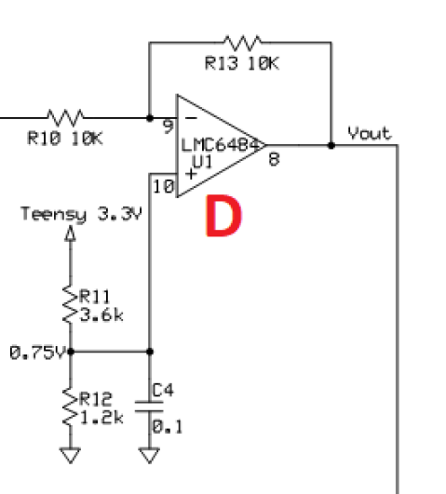

Circuit Analysis
The circuit is an inverting op-amp configuration with a gain set by the resistors R1 and R2, and a level shift introduced by Vref at the non-inverting input. Let’s derive the output voltage.
Inverting Amplifier Gain:
  - The gain of an inverting op-amp is given by:
$$Gain=-\frac{R2}{R1}​$$
  - Here, R1 = 10kΩ, R2 = 10kΩ, so:
$$Gain=-\frac{10k}{10k}=-1$$
This means the input signal at the inverting input (Vin) is inverted and amplified by a factor of 1 (i.e., no amplification, just inversion).
Effect of Vref:
- The non-inverting input (Pin 10) is set to Vref = 1.0V. In an ideal op-amp, the inverting and non-inverting inputs are virtually equal due to negative feedback. The output adjusts to make the voltage at Pin 9 equal to Vref (1.0V).
- The output voltage (Vout) for an inverting configuration with a non-zero reference voltage at the non-inverting input is:
$$Vout=Vref-(\frac{R2}{R1})⋅(Vin-Vref)$$
Substituting R2/R1 = 1 and Vref = 1.0V:
$$Vout=1.0-(Vin-1.0) =1.0-Vin+1.0=2.0-Vin$$

Therefore, Output Voltage Formula: [ Vout = 2.0 - Vin ]
- Input Range: −0.5V to +0.5V (1V peak-to-peak triangle wave).
- Output Range:
  - When Vin = −1.5V: ( Vout = 2.0 - (-1.5) = 3.5V )
  - When Vin = +1.5V: ( Vout = 2.0 – 1.5 = 0.5 V )
  - Output is an inverted triangle wave, 1.0V to 3V (1V peak-to-peak), centered at 2.0V.
Test result:
For the prototyping circuit: actual Vref=1.1V, desired triangle signal [-0.5V, 0.5V] at 1Hz from Pin_7 of AD5761, the actual triangle signal [-0.75V, 0.57V] at 1Hz.
The output from Pin_8 is triangle wave [1.57V, 2.92V], agreeing with the calculation formula.

